**1. Introduction to ALB Ingress SSL**

--- **note** – we are going to implement kubernetes ssl use case.

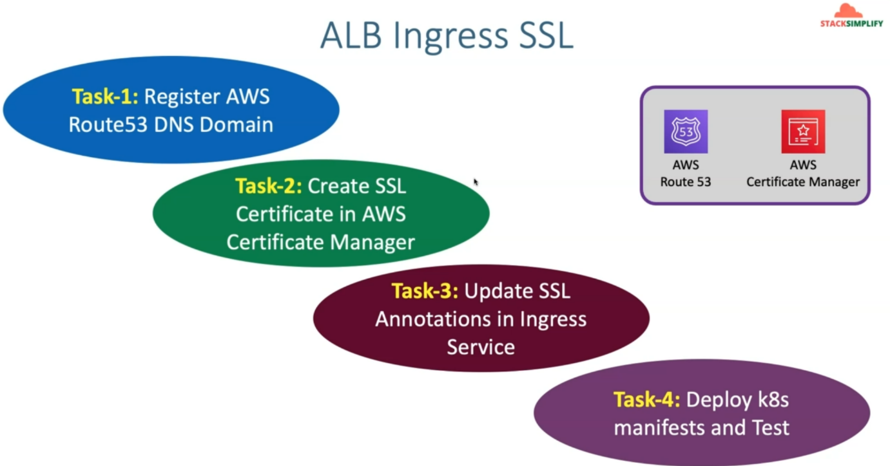

--- we are going to interduce 2 more services as part of the use case.

1. Aws route53
2. Aws certificate manager

--- as part of task one, we are going to register a new domain in AWS Route53. So this is just to learn how to register a domain in AWS route53.

--- as part of the task 2, we are going to create SSL certificate in aws certificate manager.

--- as part of task 3, we are going to update the SSL annotations in the ingress service and deploy those Kubernetes manifest and test it using Task 4.

**Network design for aws SSL certificate implementation**

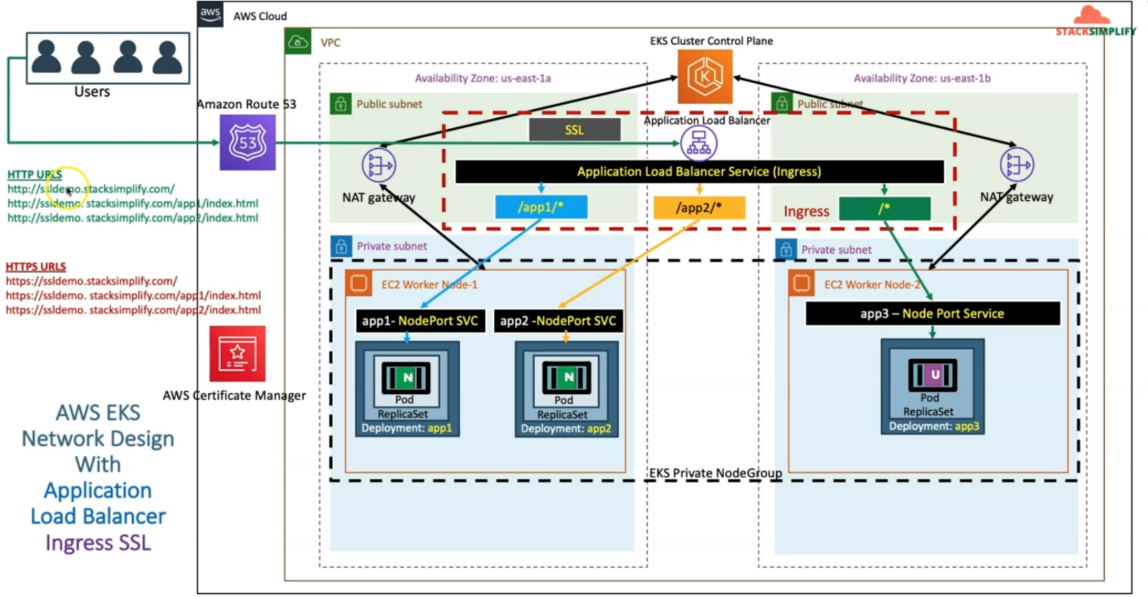

--- we have already seen in the context-based routing use case.

--- we are also going to add aws route 53 related service here and also ensure that we register new domain inside this route 53 service.

--- we're also going to create SSL certificate in the Certificate Manager Service and we're also going to update our ingress service with SSL related annotations and finally, we are also going to DNS register our application load balancer DNS name with that custom DNS name. with something like ssdemo.stacksimplify.com in the rout 53 as record.

--- whenever we access http URL then all three applications app1, app2 and app3 should be accessible for us and we will be also able to access using https://ssldemo.stacksimplify.com for all three applications with their respective context path.

--- In addition to this, we are also going to implement SSL redirect.

--- So, whenever you access the http url, it will directly redirect to https url. but this is in the next demo

--- in this demo. We will see the URLS in independent model where you can access the application with what http and https URLS.

**Important notice**

